

Submitted by : Spogmai jan
Roll no : 2430 - 0081
Course : coal lab
Date of submission : 20/02/2026
Submitted to : sir mujtaba

Assignment no : 02

Question :01
) Use register command 'r' at the DEBUG prompt. Note down all the registers with their contents Change the contents of following registers with values shown below:
DX:
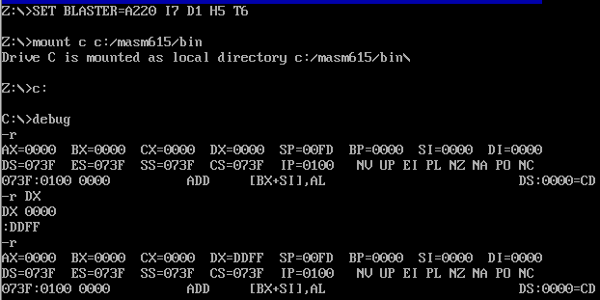
cx
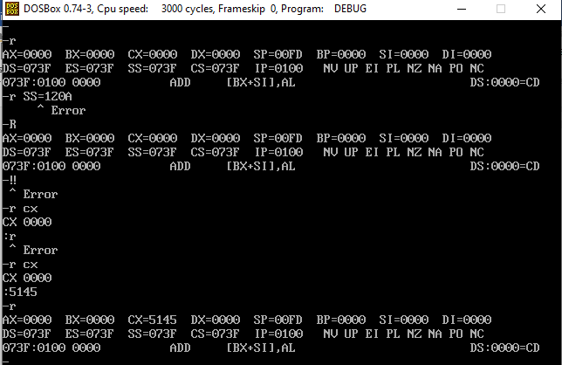

Ax
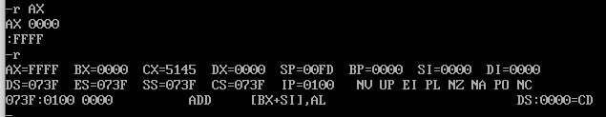
BX:
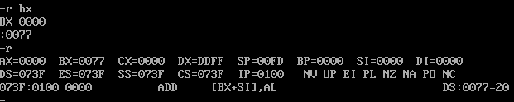
SI:
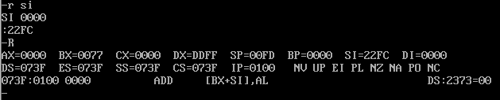
DI:
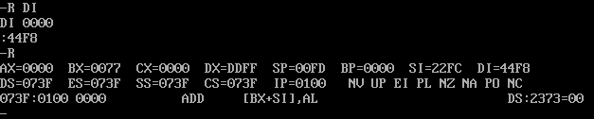
DS:
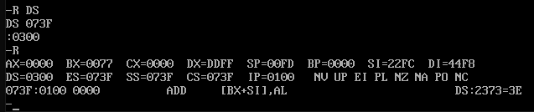

CS:
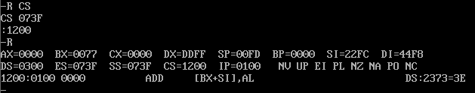
ES:
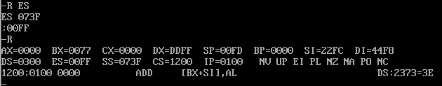
SS:
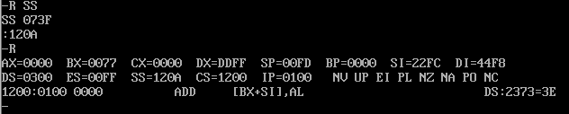
===========================================
Question :02
Display memory contents within range of offset address 140(hex) and 148(hex)
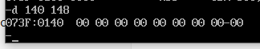
Enter data 44(hex) into location 100(hex) to 10f (hex) and verify that contents are changed.

Enter data "My name is …….. I am student of SSCASE University" at location DS:100 and verify that contents are changed
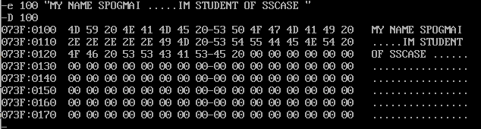
Use fill command to enter data ff to location 100 to 12f. Verify result.
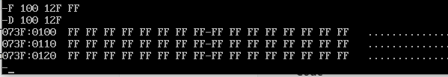
Use fill command to enter data “My name is ……..” In to location DS:100 to 200. Verify result.
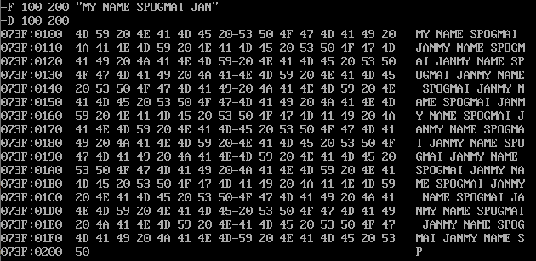

Use fill command to enter data “Centre for Advanced Studies in Engineering” in to location DS:300 to 305. Verify result.
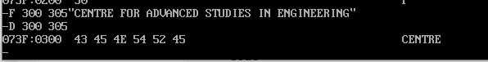

=======================================

Question :03
- Fill memory location DS:300 through DS:3FF with data 44h. Use dump command to keep record of data in location DS:300 through DS:3FF and location DS:400 through DS:4FF. Move block of data from memory location DS:300 through DS:3FF to memory location DS:400 through DS:4FF

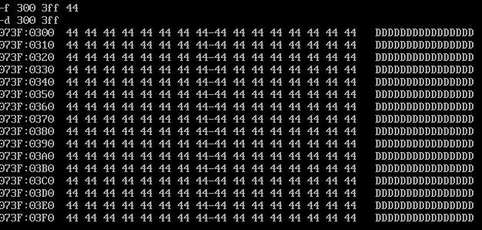

Move block 300–3FF → 400–4FF

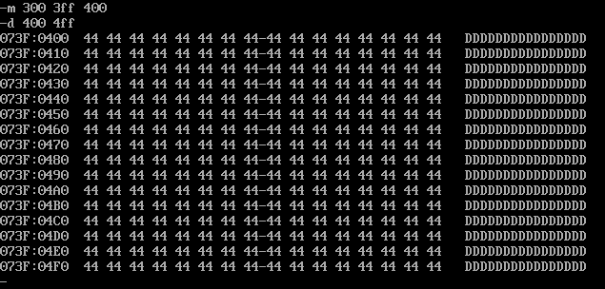

- Fill memory location DS:0100 through DS:011f with data 11h and location DS:120 through DS:013f with data 33h. Perform a search of block of data from address DS:100 through DS:013f to determine which memory locations contain 33h

Fill 0100–011F with 11h

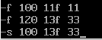

Fill 0120–013F with 33h

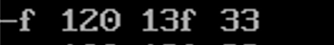

Search for 33h



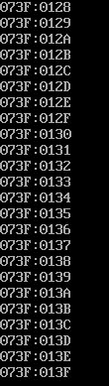

- Using H command find sum and difference of following hexadecimal numbers.
ABC0 0FFF 8888 0888 BCDA 0DCA
H Command (Hex Calculations)
First result =sum
Second result = Difference
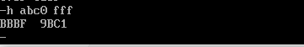
8888 and 0888
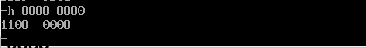
BCDA 0DCA
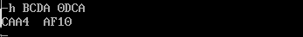

- Find negative of following hexadecimal numbers.
0008, 0128, 0007, AFCC
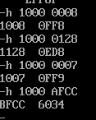

- Move data from DS:231 to memory location DS:231 and verify.

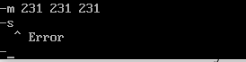

- Fill memory location DS:142 through DS:148 with data "..wec.." and location DS:120 through DS:013f with data 63(Hex). Perform a search of block of data from address DS:142 through DS:148 to determine which memory locations contain 63h..

Fill 142–148 with string:
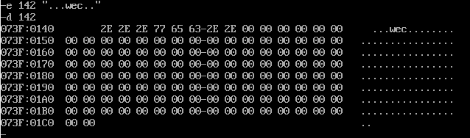

Fill 120–13F with 63h:
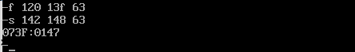

g.Fill memory location DS:9 through DS:14 with data 12(hex) and location DS:20 through DS:26 with data 21(hex). Compare these two blocks of data using compare command. Note down results. Fill memory location DS:20 through DS:26 with data 12h. Again compare two blocks of data and comment on results

Compare Command

: Fill 9–14 with 12h:

Fill 20–26 with 21h:

Compare 9 14 20:
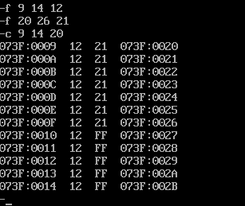

Again:

Fill 20–26 with 12h:
Compare 9 14 20:



